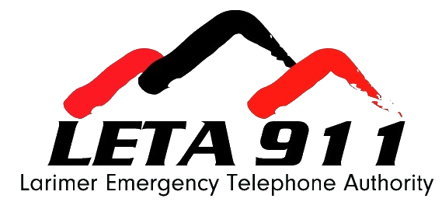

Quality Assurance Analyst Job Description
**Personnel Contract**

Department: | Operations – Quality Assurance
Employment Status: | Contract
Pay: | $22/call  $30/hour other tasks as assigned
Revised: | July 2025

Position Purpose
The purpose of this position is to provide quality assurance (QA) review on 911 calls for the Public Safety Answering Points (PSAPs) within Larimer and Jackson Counties.

This position requires solid working knowledge of Emergency Medical Dispatch (EMD) protocol through the International Academies of Emergency Dispatch (IAED). Employees will exercise independent judgement in the performance of their duties and handle moderately complex issues and problems.

Duties and Responsibilities

- Conduct case reviews of calls as assigned, for each certified user at each PSAP to monitor compliance with IAED medical protocol standards.
- Participates in calibration cases to ensure consistency throughout the QA team at the Authority.
- Attend internal QA meetings to discuss protocol questions and concerns and plan training topics.
- Maintain competency in currently used protocol software and participate in training on new software.
- Perform all other related duties as required by management.

Note – Duties and responsibilities listed may be carried out in-person or virtually. Timely and consistent engagement is an essential function in the performance of this job.

Knowledge, Skills, and Abilities

Knowledge Of:
- Principles and practices of the IAED medical protocols.
- 911 Call-taking policies and procedures for medical calls.
- Federal, State, and local laws, codes, and regulations related to public safety.
- Quality assurance and improvement principles and practices.
- Microsoft Word, Excel, and Outlook.​

Ability To:
- Think critically using logic and reasoning to identify potential solutions, conclusions, or problem approaches.
- Maintain the confidentiality of records and information.
- Establish and maintain effective working relationships with PSAP employees, partner agencies and Authority members.
- Monitor the performance of PSAPs as it relates to medical protocol compliance.​

People Skills:
- Communicate clearly and concisely, both orally and in writing.

Relevant Education, Experience and Certification Requirements

Education:

High School Diploma/GED is required.

Experience:
At least 3 years working in a public safety emergency communications center (PSAP) using the current IAED protocol system or a related field.

Certifications and Licenses: Must possess the following certifications and/or licenses as outlined below:
- Possession of an IAED EMD-Q certification is required.
- Possession of a nationally recognized Cardiopulmonary Resuscitation (CPR) certification is required.

All required licenses and certifications must be maintained throughout the term of employment.

Technical Skills:
This position requires knowledge and trained proficiency in the following software:
- ProQA
- Microsoft Office Suite
- AQUA
- NICE
- Imprivata

Additional Information
Supervision Exercised:
This position does not exercise any supervision.

Supervision Received:
This position performs duties under the general supervision of Larimer Emergency Telephone Authority (LETA) Chief of Staff.

Locations
- QA responsibilities may be carried out in-person or virtually.

Compensation Structure
- Call Review
$22.00 per completed call graded. A "completed call" includes full review and documentation of the call per provided guidelines and standards.
- Other tasks (as assigned)
$30.00 per hour for additional duties outside of call grading, including but not limited to meetings, training, special projects, and administrative support.

Payment Terms
Contractor will submit an invoice detailing the number of calls and the hours worked on additional tasks. Payment will be processed bi-weekly following invoice approval.

Disclaimer
The above statements are intended to describe the general nature and level of work performed by employees assigned to this position. It is not designed to contain or be interpreted as a comprehensive list of all duties, responsibilities, and qualifications. The Authority management reserves the right to amend and change responsibilities to meet business and organizational needs, as necessary.

To apply, email your resume and a cover letter to hr@leta911.org.
Position will be open until filled.

